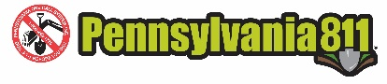
2026 PA Safety Days

Hotel Information
The following hotels are offering courtesy room blocks. When the block ends or exceeds its limits, the offer will expire. If you have any questions about reserving a room, please contact the hotel directly.

Monday, September 21, 2026 – Oaks (the night before Safety Day)
Hilton garden inn valley Forge/Oaks, 500 Cresson Blvd, Phoenixville, PA 1946
Group Name: Pa 1 Call Safety Da
Click here: https://www.hilton.com/en/book/reservation/rooms/?ctyhocn=PHLPOGI&arrivalDate=2026-09-21&departureDate=2026-09-22&groupCode=92M&room1NumAdults=1&cid=OM%2CWW%2CHILTONLINK%2CEN%2CDirectLink

Wednesday, September 23, 2026 – Wilkes-Barre (the night before Safety Day)
Mohegan Pennsylvania Casino Resort, 1280 PA-315, Wilkes-Barre, PA 18702
Click here: https://book.passkey.com/go/VEN0926

