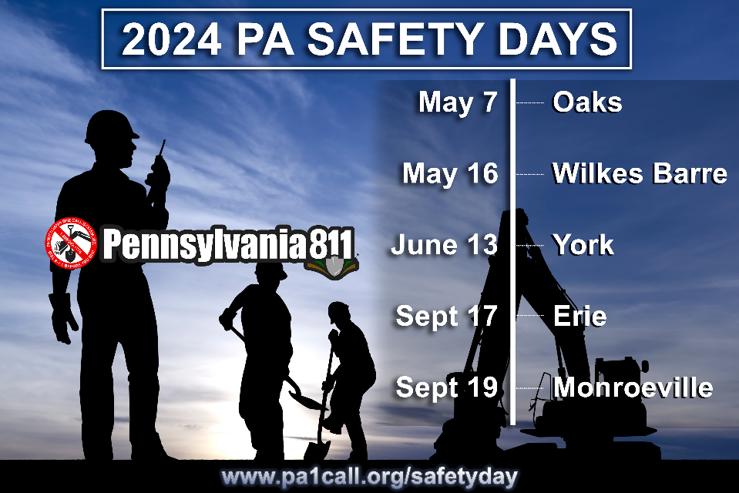

**ANNOUNCING**

**THE BURIED TRUTH**

Keynote Speaker, Eric Giguere

In 2002, I was an average working-class guy with the attitude **“accidents happen, *but not to me*.”** Today, I am lucky to be alive.

At 27 years old, I took a chance and it nearly took away my life. Trust me when I say I can relate to every worker in my audience, because I know what you do on a worksite, what you don’t do and how you take risks every day without thinking about it.

**My message is plain and quite serious, “It can happen to you.**”

Join me at one of the PA Safety Day Conferences in 2024. Learn how you can look after yourself and your co-workers by changing your attitude and stopping unncessary shortcuts with your lives.



Changing Attitudes. Changing Lives.



**Pennsylvania 811 is pleased to announce the Keynote Speaker for our 2024 PA Safety Day Conferences will be Eric Giguere.**

Eric is a renowned national presenter who shares his inspiring story of surviving being buried alive in a preventable workplace accident and how his life changed forever.

#pasafetyday24

www.pa1call.org/SafetyDay

REGISTER ONLINE

Greater Philadelphia Expo

Mohegan Sun Casino

York Expo Center

Bayfront Convention Center

Monroeville Convention Center